How to Login to Order for September 22 BBQ

Go to https://munchalunch.com/schools/Dixon/ or click on the MunchaLunch icon on the Dixon school website (https://dixon.sd38.bc.ca/).
NEW users
- Click the "Register Here" button. The system will guide you through.
- After adding your children, select “All Grades/All Classes” as classrooms assignments are not confirmed yet. Click the yellow "Order Lunch!" button to start placing your order. Complete the entire BBQ order under your ELDEST child’s name. Your tickets will be distributed to this child before the BBQ.
RETURNING users
- Click the "Login Here" button to access your account.
- You will get this message: “Before ordering, please update your child's grade & classroom for 2022-23”. Select “All Grades/All Classes” for now. Complete the entire BBQ order under your ELDEST child’s name. Your tickets will be distributed to this child before the BBQ.
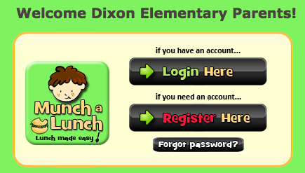

Other Tips and Information about the BBQ

Bring chairs or a mat/blanket for your child and family to sit on.
A concession stand will be organized onsite by the Dixon PAC. Please bring cash and coins!

If you are interested in volunteering for the BBQ or have questions, please contact Lisa at munchalunch.dixon@gmail.com.

